Rudra Dave Lab3 report

Terraform Apply

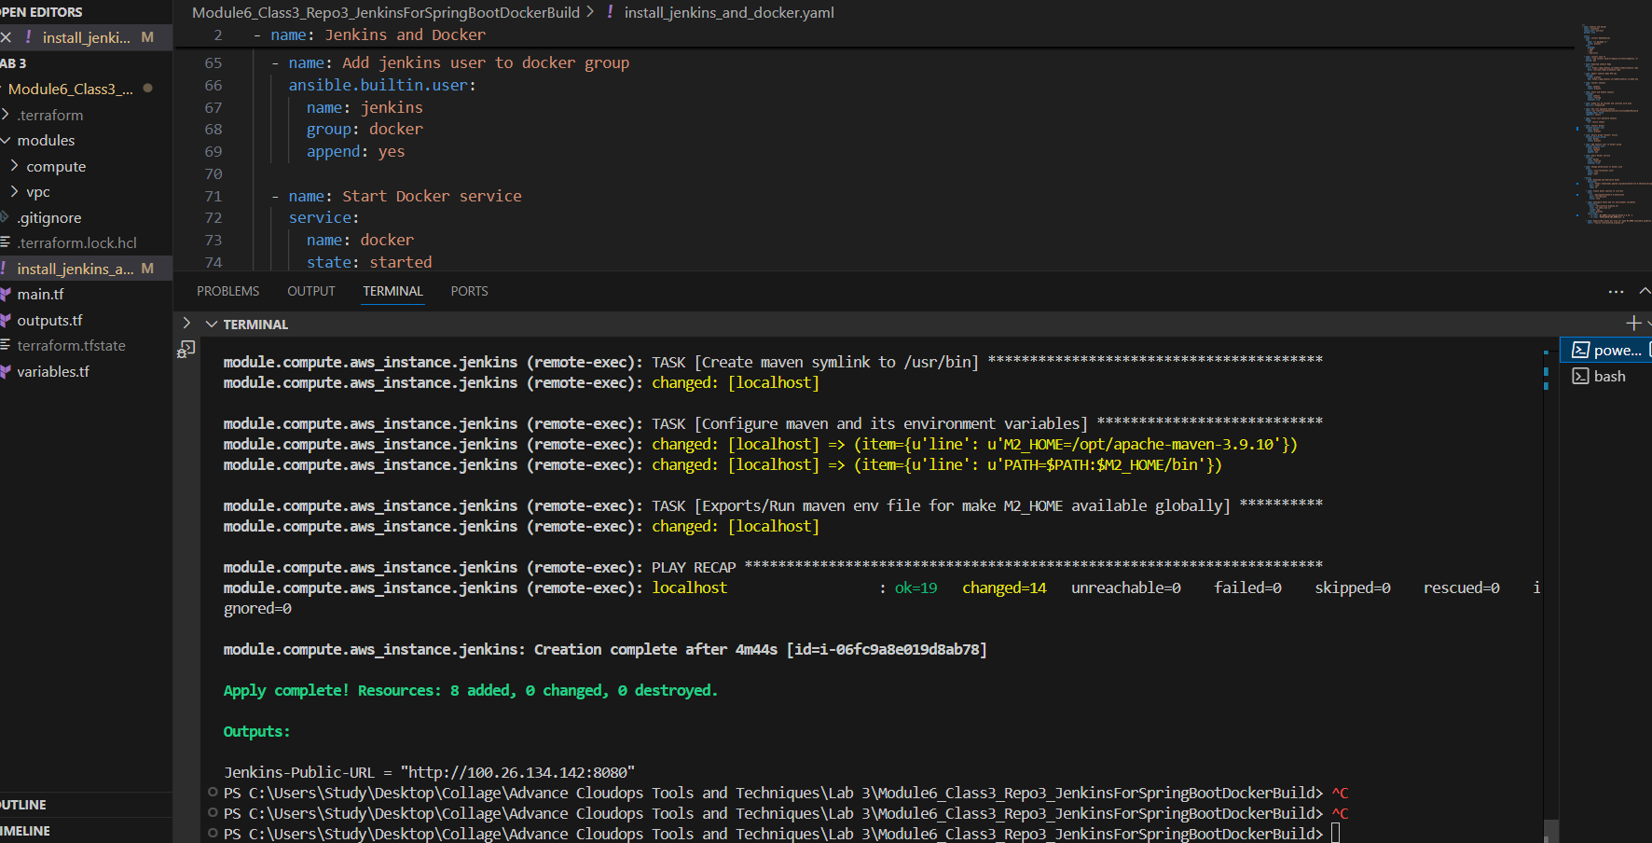

Docker Hub Repo

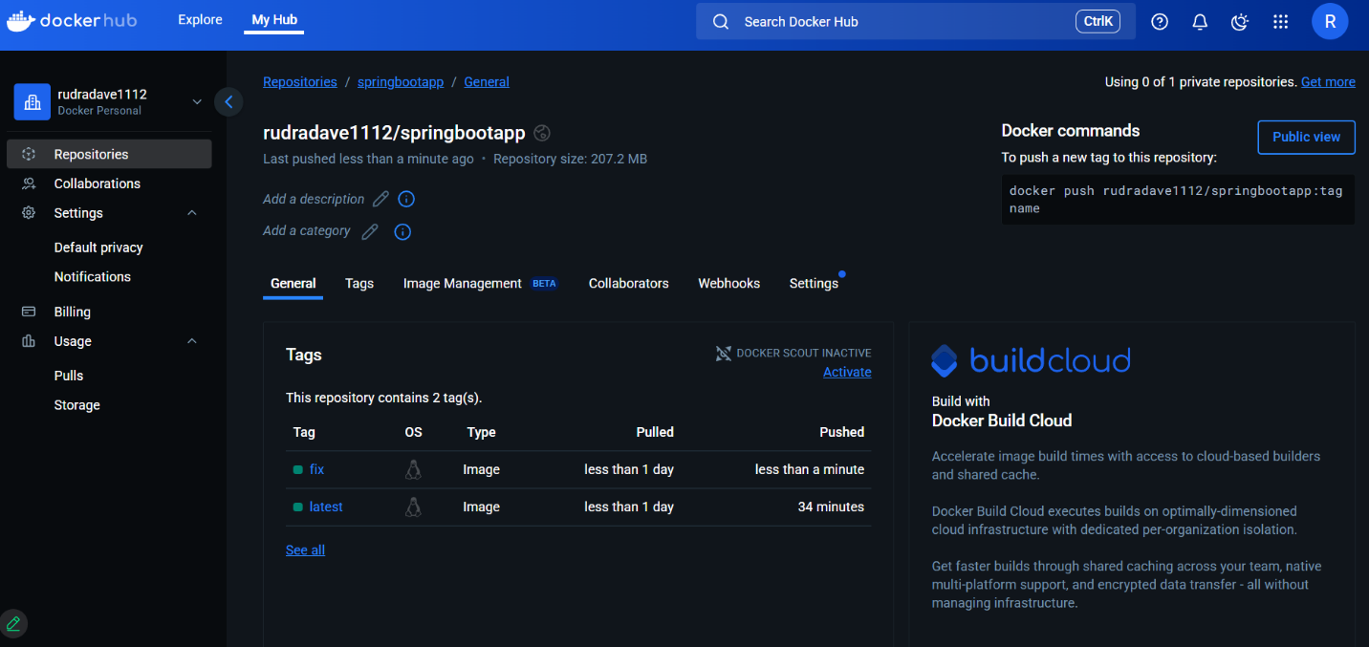

Snyk Dashboard

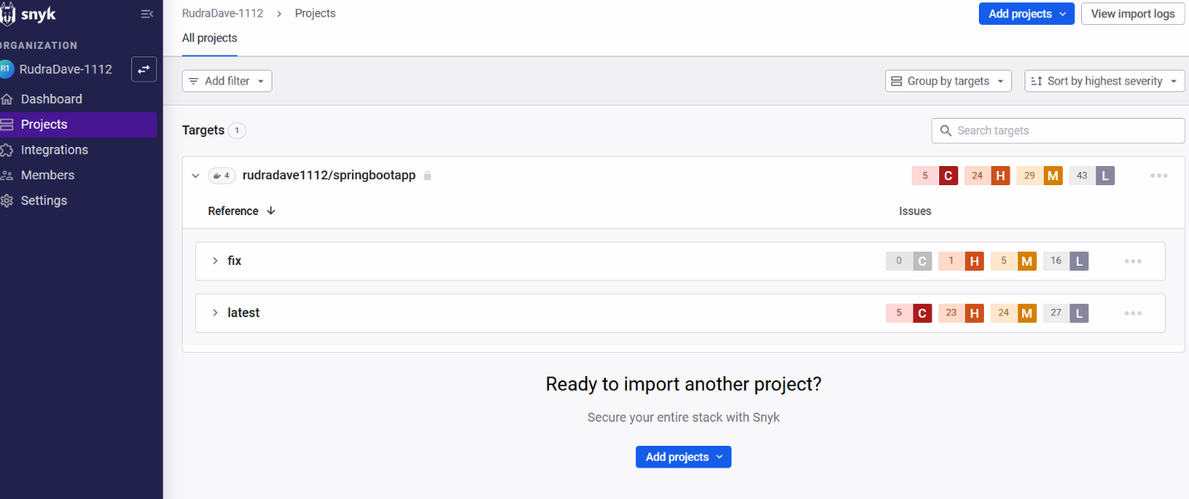

As observed, the latest branch currently reports **5 critical** and **23 high** severity vulnerabilities. After upgrading the relevant dependency versions in the pom.xml file, we were able to significantly improve the security posture in the fix branch. The updated scan now shows **0 critical** and only **1 high** vulnerability remaining. This reflects a substantial reduction in risk, demonstrating that the dependency updates were effective in addressing the majority of the previously reported issues.

Kubernetes deployment with rolling update strategy (Branch: Latest)

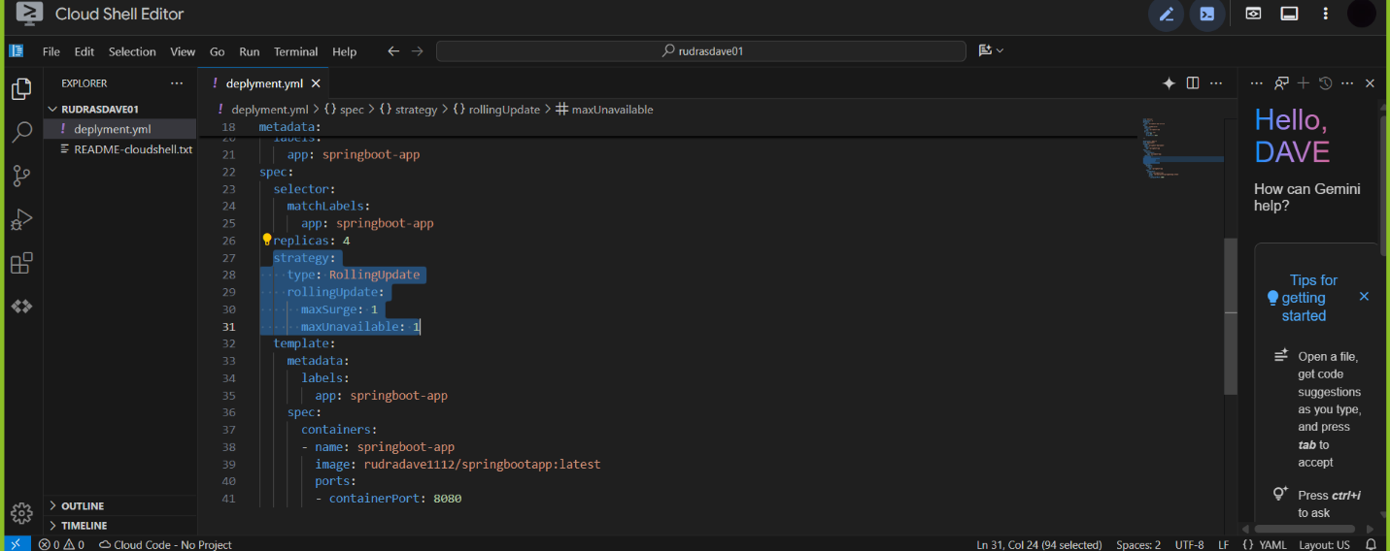

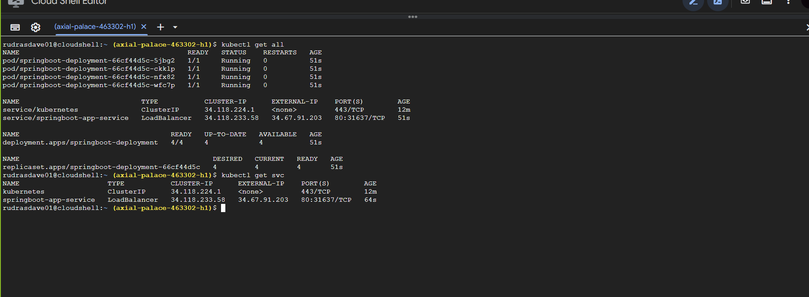

Output (Branch: Latest)

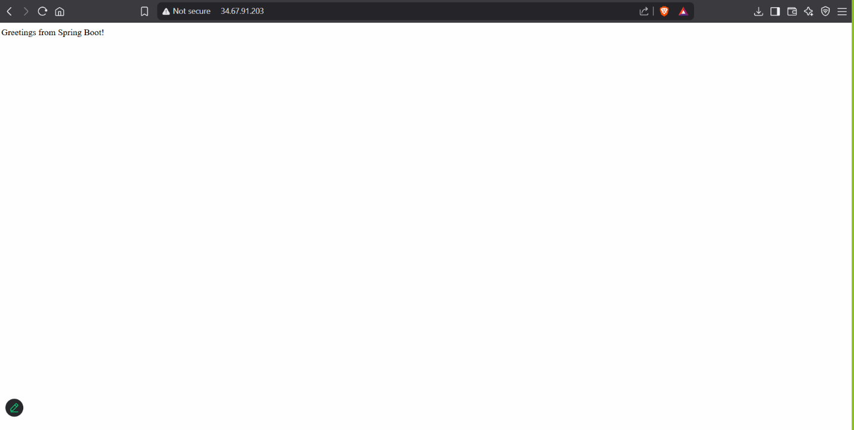

Kubernetes deployment with rolling update strategy (Branch: Fix)

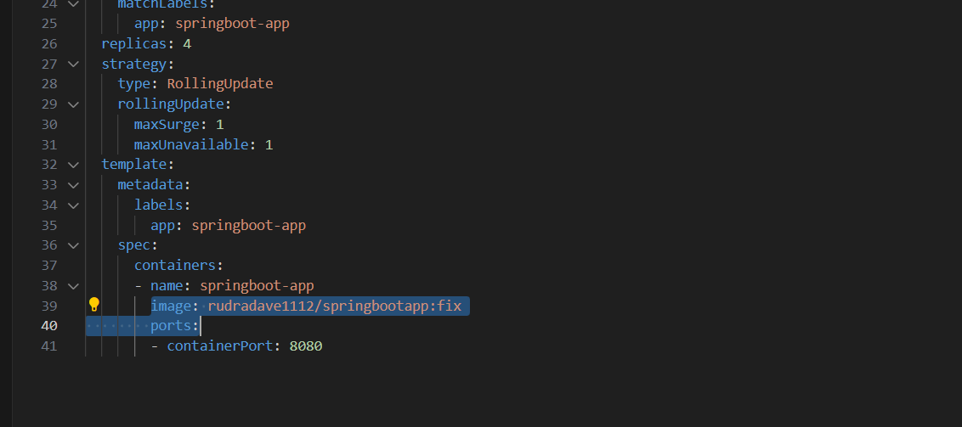

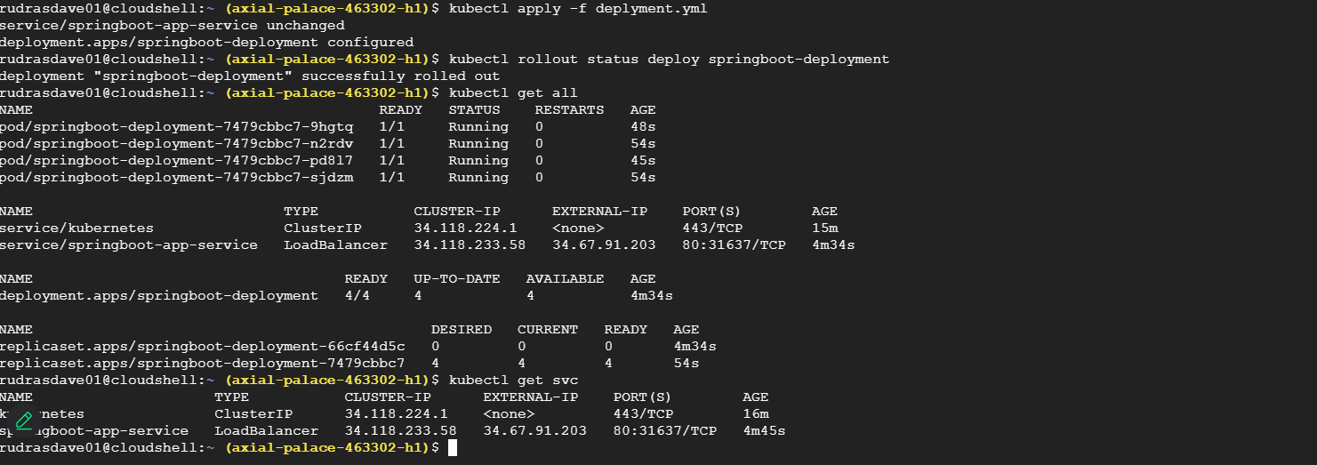

Output (Branch: Fix)

